Welcome to the Staff Hub pages for the Medical Compliance Team at Liverpool University NHS Trust (LUH).

Payslip and Abbreviations
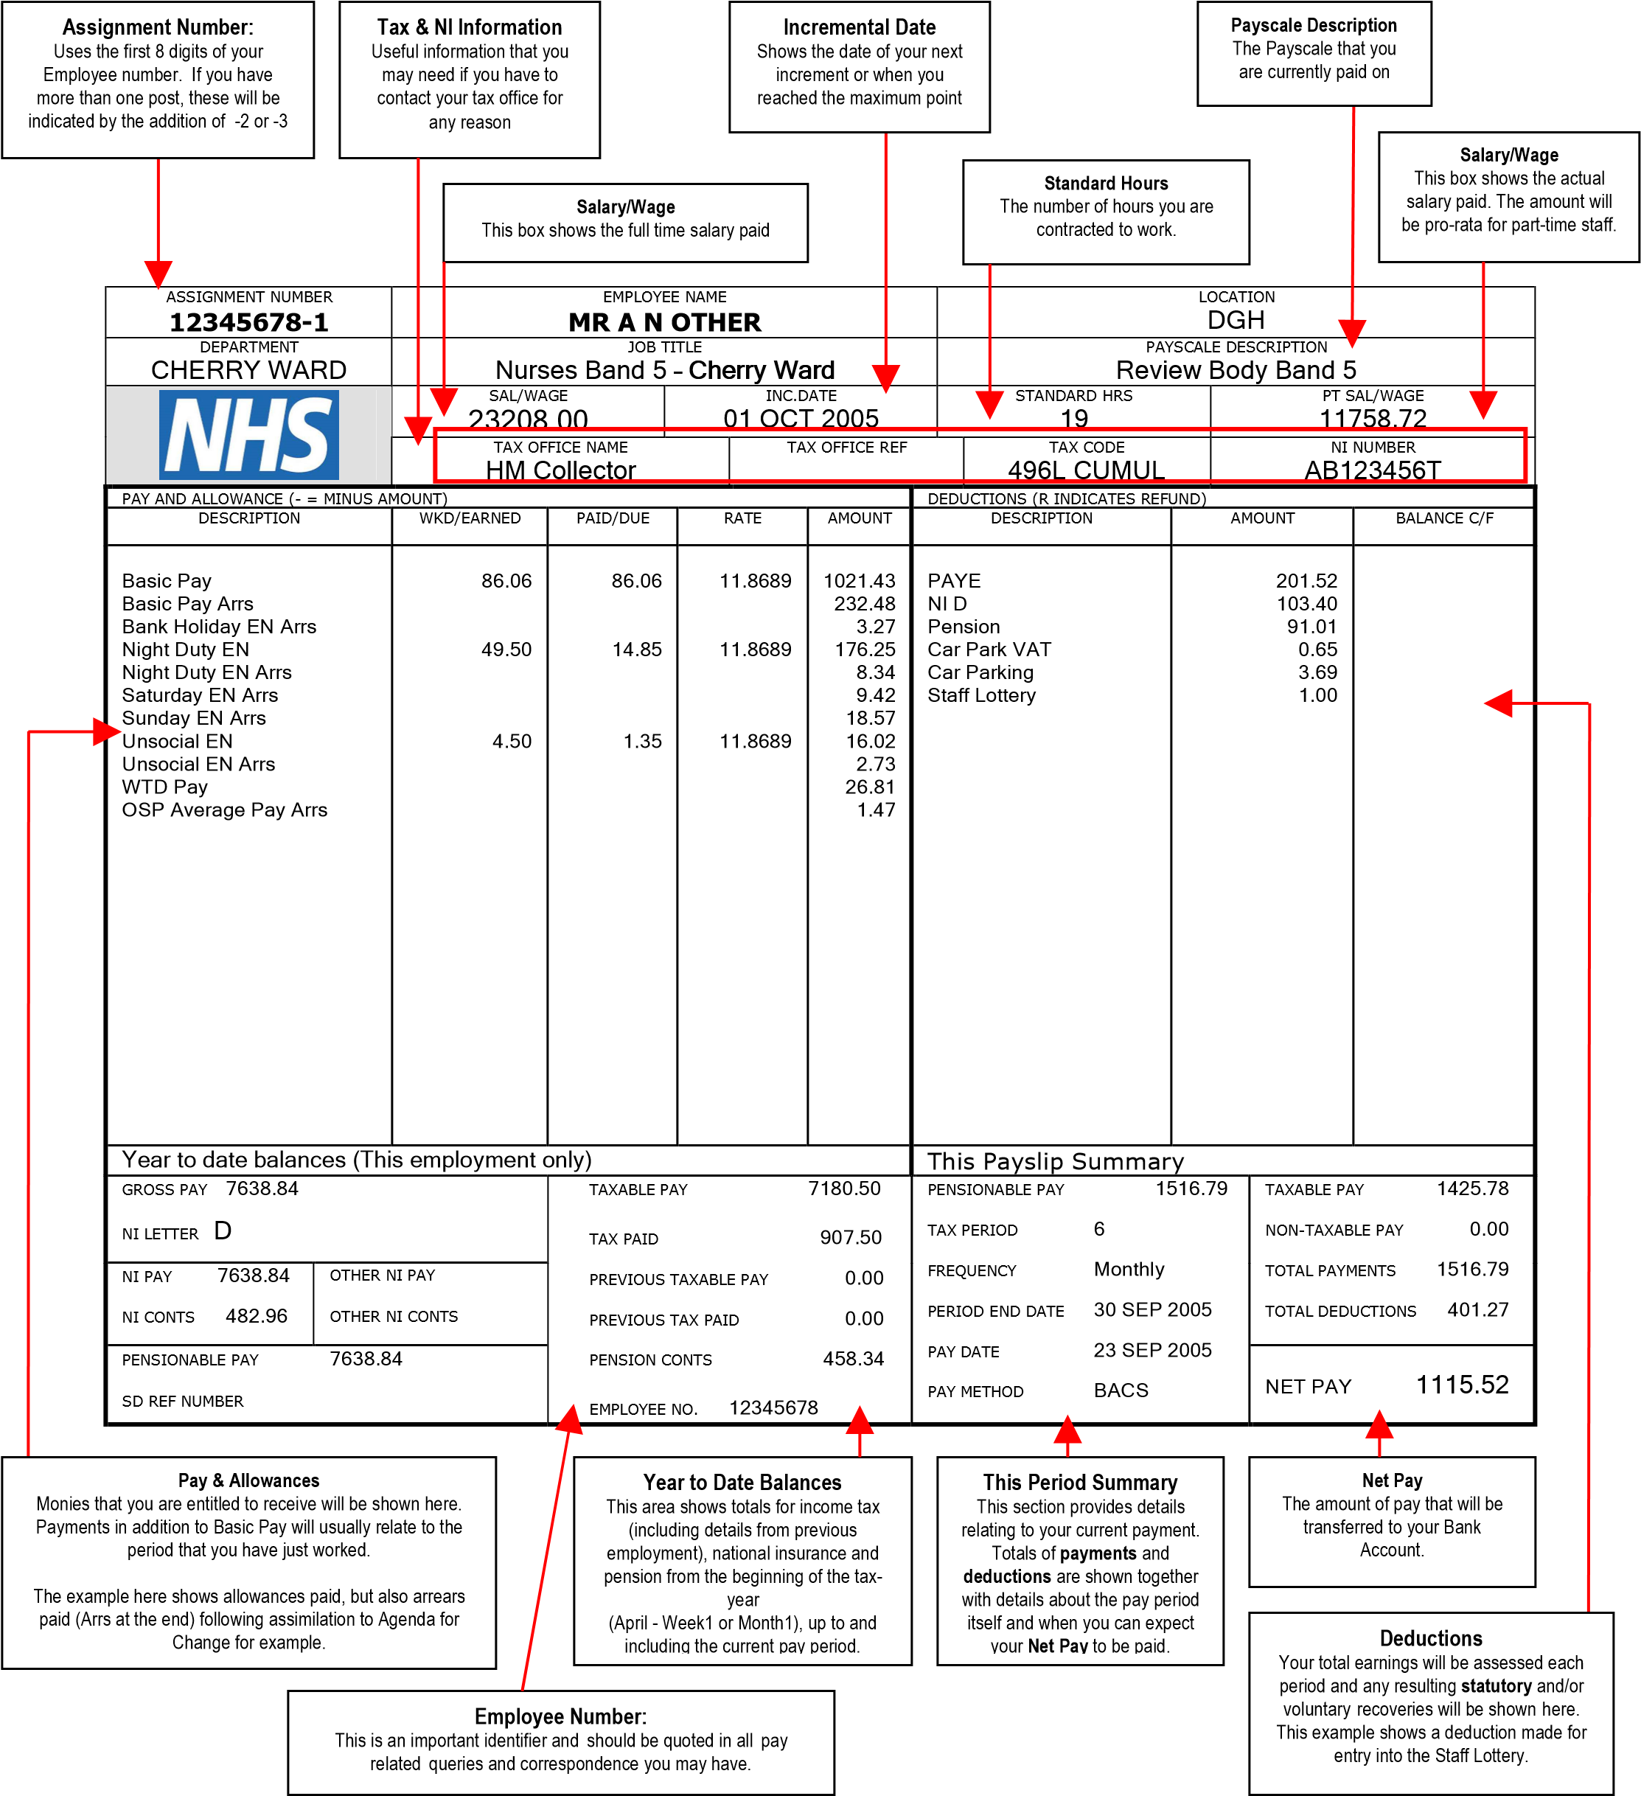

Common abbreviations used on Payslips
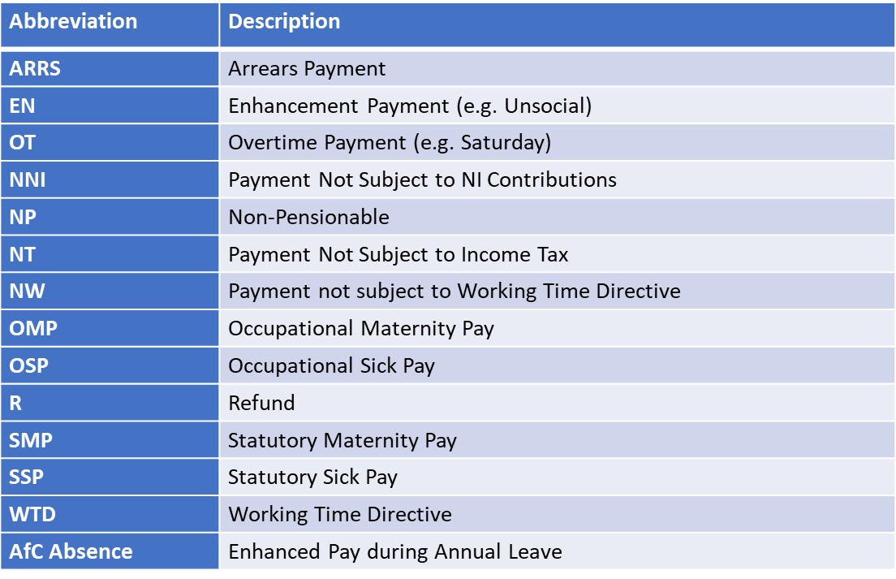
Payroll Contact Details
Payroll, Pensions, please contact STHK at payrollluh@sthk.nhs.uk

